KIAN GAULT (Student)

OOP Solutions ltd  WLC- Graded Unit – HND: Software Development

Simply Rugby Management Systeme – User Manual

Contents

Purpose 2

User: Admin 3

Login Window: Admin: 3

Player Details Window: 4

User: Coach 9

Login Window: 9

Player Details Window (Coach) 10

Skill Profiles Window: 12

# Purpose

The purpose of this user manual is to give a full walkthrough of how to use this system and all it’s functionalities.

This document may be used as a guide for any future employees of the client organisation and will also serve as a guide on how to manage the system for veteran staff who might be transition over to a computerised system.

The layout of this user manual will be split into the five possible users within this build. These are the Administrators, Junior Coaches, Under 18s Coaches, 18+ Coaches and 21+ coaches.

All these users have different permission access levels and operations so it’s important each role is clearly outline and explained. Screenshots will be giving alongside the verbal descriptions.

# User: Admin

## Login Window: Admin:

* The admin will first be identified on the login screen. This is achieved by entering your admin login id and password. If this is a match for an already stored admin account, you will be giving access and taken to the hub window.
* If you have successfully logged in as an admin then your role and ID should resemble as an admin at the button right corner of the hub screen.

## Player Details Window:

* This window is where you as an admin will do majority of your operations. Here you can create a new record on any team, update a record on any team, delete a record on any team and search for any record on a team.
  + Let’s start with creating a new record.
    - This is achieved by enter data into all the boxes provided and selecting a date from the date picker for the players DOB. Don’t worry about getting the age wrong for the team you are currently looking to create a player for. The date picker pre-sets the date range for you whenever you change team.
    - Don’t forget to choose if the player has parental consent if they are an under 18s player!.
    - 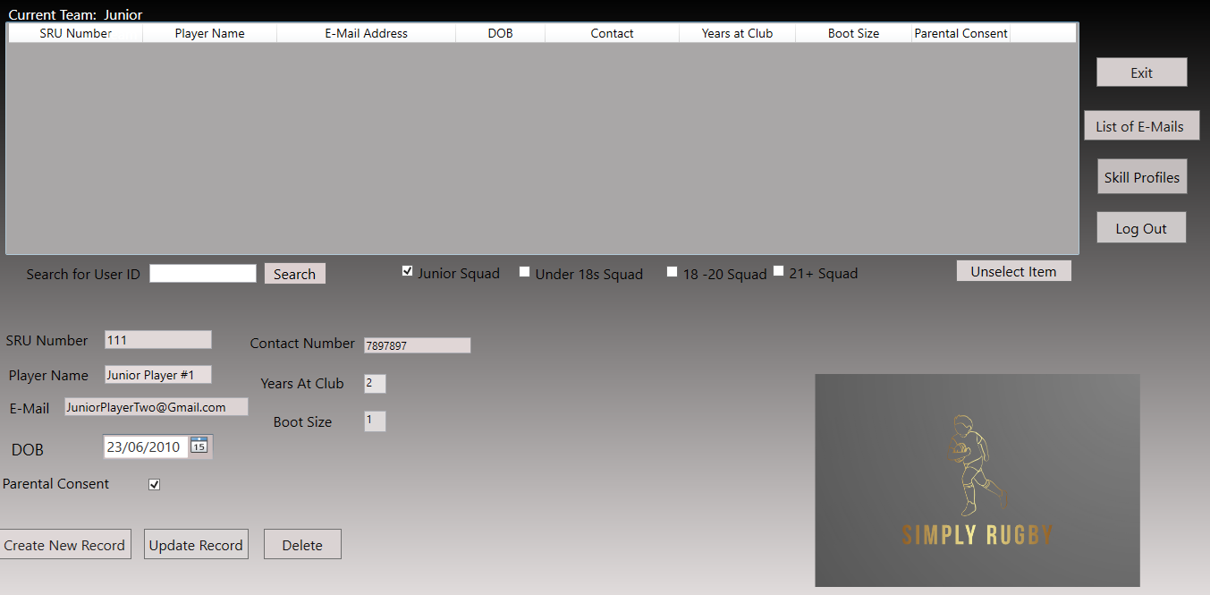A screenshot of a computer

      Description automatically generatedOnce you have filled all this data out, you simply need to press create and if all the data is valid the new player record will display on the list. This shows that the data was updated to the database
  + Next, lets look at updating this existing record:
    - To do this, you simply need to click on the record you just created on the list.
    - Once you do this, all the boxes will be pre populated with the record you selected. This means you can get to editing right away!.
    - Editing any of the fields you wish to update, for this example I will change the SRU number to 112 instead of 111.
    - 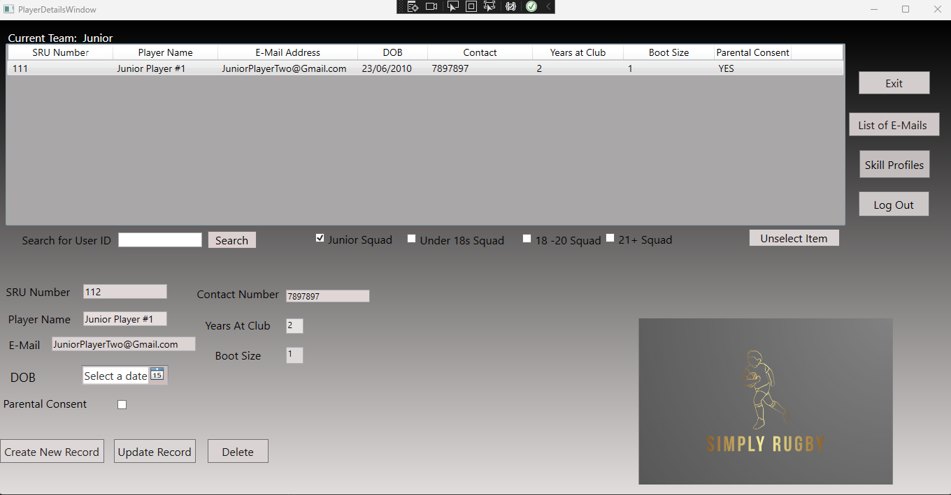A screenshot of a computer

      Description automatically generatedPress the update when you have finished and the record will be updated successfully.
  + Now that we have covered creating a record and updating a record, lets cover deleting a record.
    - To delete a record, you follow the same principle as updating a record by selecting a record from the list.
    - Once selected the selected users records will populate in the boxes for you.
    - 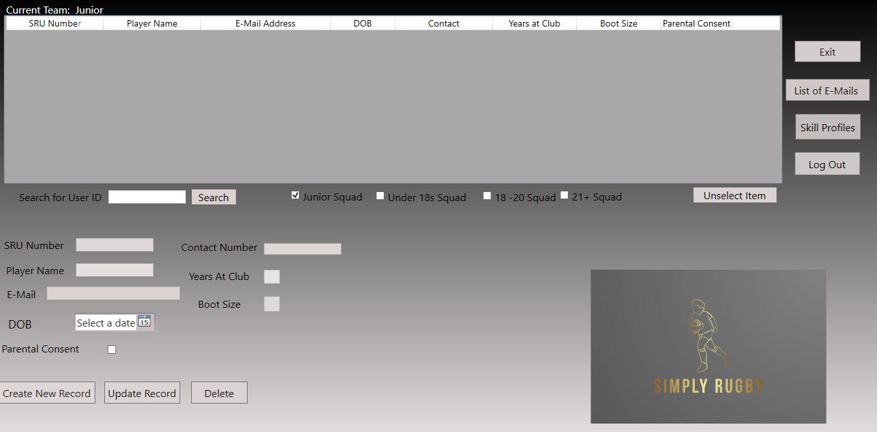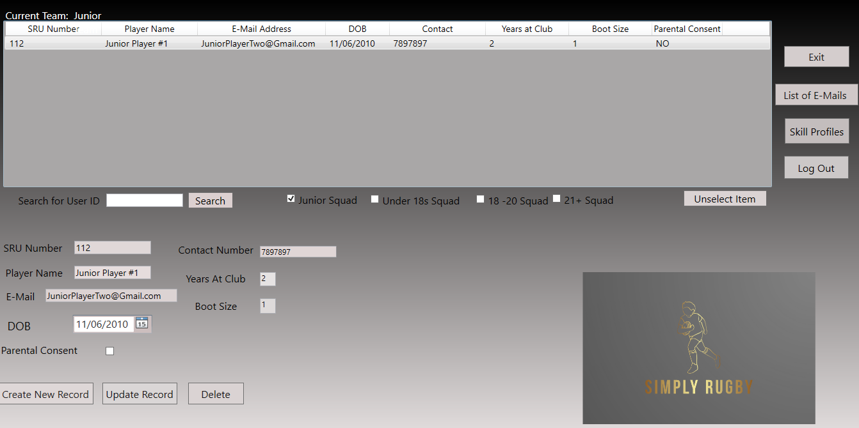From here you simply click delete and the user will be fully removed from the database.
  + Finally, the last operation you can perform with the database is searching for a record.
    - We don’t have any records at the moment but we can create some!
    - This would be an excellent time to try out switching teams. This is simply done by checking the check box of the team you wish to change to.
    - In my example I will switch to one of the senior teams to demonstrate how these teams do not have a consent checkbox as they are adults, so no parental consent is needed. Make sure to create at least two new records on the same team so we can test the search feature!
    - 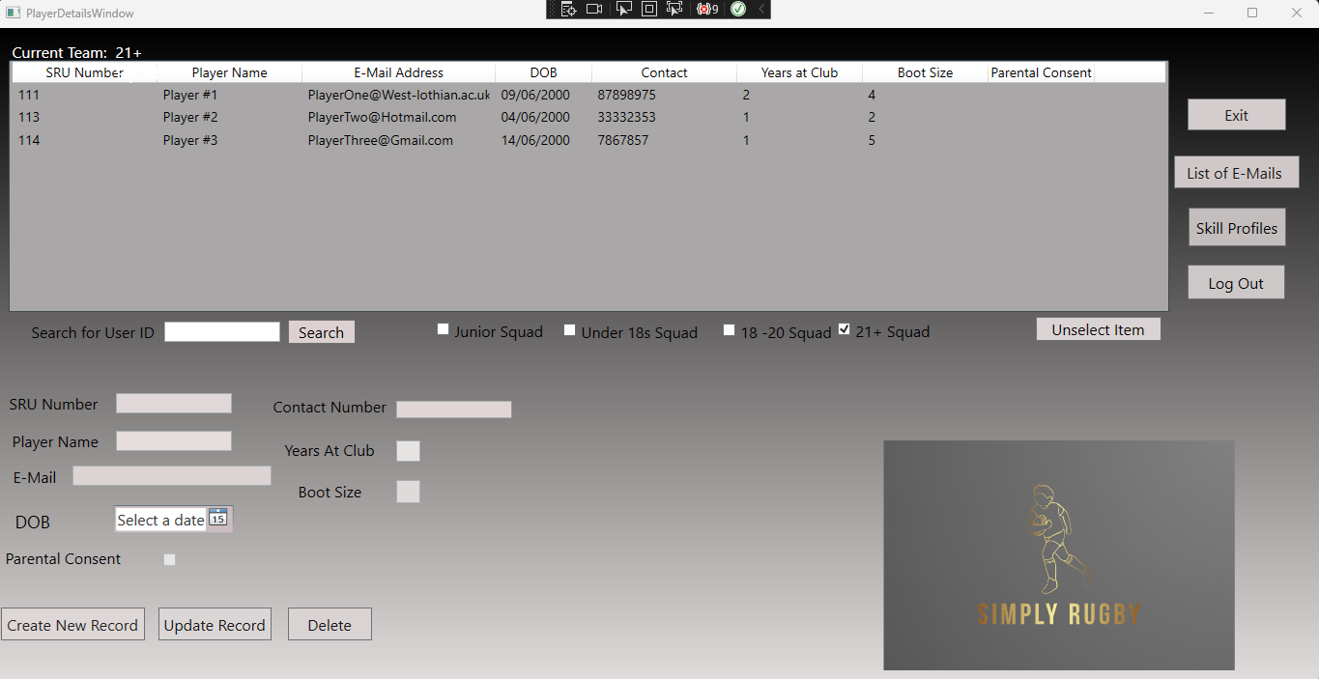Graphical user interface, text, timeline

      Description automatically generatedOnce you have a created a record in a table of your choice, enter the player SRU number into the search box beside the search button.
  + The final operation you can perform as an admin is view the list if E-Mail addresses for all the players.
    - This is done by clicking on the “List of E-Mails” button.
    - Once here, you can view all the teams email addresses by checking the checkbox of the team you wish to view.

# User: Coach

## Login Window:

* The login window is the same process for the coach as it is for the admin.
* Simply enter your login details and the system will validate that you are a coach. Remember the logins are case sensitive!
* You will be assigned the type of team you currently manage i.e. Junior, Under 18s, 18+, 21+ Coach.
* This will be displayed on the hub window for you. This is a process in giving permission access to you.
* Graphical user interface, website

  Description automatically generatedIn this example I will use the Under 18s Coach login:

## Player Details Window (Coach)

* The coach user has access to the player details database but this access is very restricted.
  + The access levels are giving to each of the different coaches. E.g. the junior coach will be able to view the Junior Team records but the 21+ team records. Just like the 21+ coach cannot view the junior records.
  + No coach can create, update or delete player detail records even their own teams. This is an admin privilege only.
  + The coach is able to search for a record on their team with the search box.
  + A screenshot of a computer

    Description automatically generatedIn this example I will demonstrate viewing the personal records as a under18s coach.  
      
      
      
      
      
      
      
      
      
      
      
      
      
      
      
      
      
    Attempt to switch teams:

* + The coaches also have the ability to view the emails for their team.
    - By clicking on the button list of e-mails you will be brought to the list of emails window.
    - Note that you cannot switch between the current displayed team.
    - Before loading the list, the system will check to see what type of user has entered the window. This means if you enter the email list window as a 21+ coach you will be shown the 21+ email list.

Attempting to switch E-mail list:

## Skill Profiles Window:

* This window is where the coach users performs their main action. Updating skill profiles for existing records.
  + The Junior Coach is able to update the skill profiles for Junior members.
  + The Under 18s coach is able to update the skill profiles for under 18s members.
  + The 18 + coach is able to update the skill profiles for 18+ team players.
  + The 21+ coach is able to update the skill profiles for 21+ team players.   
    - To update a skill rating, the coach selects a range of 0 to 5 from all the combo boxes provided for each skill.
    - By default when admin creates a new player, their skill ratings are set to 0. It is the job of the coach to update these skill ratings to match their real life performance.
  + A screenshot of a computer

    Description automatically generatedIn this example I will show me updating the skill profiles for the 18+ team while logged in as the under18s coach user.



Attempting to switch to a team I don’t have access to:

* + The other operation the coach can do on this window is search for a specific profile.
    - This is achieved by entering the players SRU number that you wish to view.
      * Note: You can only search for a player on the current team.

